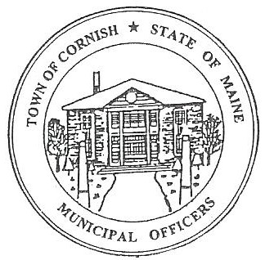
Town of Cornish
PLANNING BOARD
17 Maple Street
Cornish, Maine 04020
Telephone: 207.625.4324 Fax: 207.625.4416 E-mail:planningboard@cornishme.com

WORKSHOP MEETING AGENDA
5:30 p.m.

Monday, January 15, 2024

- Call to Order:

- Adjustments/Additions to the Agenda:

- Communications Received/Sent:

- Hilary Grove - Maine Department of economic and Community Development.
- Ref. to LD 2003.
- January 25, 2024, from 2-4pm at the Bonney Memorial Library in Cornish.
- Q & A session about the legislation.
- Review minutes - 01-08-24.

- Old Business:

- Mikala Jordan.
- SMPDC updates. (Southern Maine Planning and Development Commission).
a. Relating to LD 2003 ordinance.

- New Business:

- Miscellaneous: Reminder January 15, 2024, meeting start at 5:30 PM.

- Public Comment:

- Agenda Items for Next Meeting: Business – Monday February 5, 2024 @ 5:30 PM

- Adjournment

