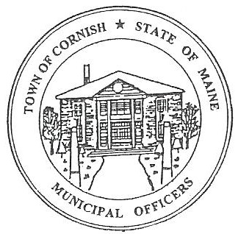
Town of Cornish
PLANNING BOARD
17 Maple Street
Cornish, Maine 04020
Telephone: 207.625.4324 Fax: 207.625.4416 E-mail: planningboard@cornishme.com

BUSINESS MEETING AGENDA
5:30 p.m.

Monday, January 08, 2024
- Call to Order:

- Adjustments/Additions to the Agenda:

- Communications Received/Sent:

- . Colby Spencer -1167 Sokokis Trail, Cornish
- Inquiring about a Conditional Use Permit.
- Mike Chasse inquiring about attending a Planning Board Meeting.

- Review of Minutes:

A. 12-04-2023

- Old Business:

- New Business:

- Ashley Pingree – Cornish Hair Studio – ref. U06-007-1.
- Kathrine Farris – ref. U03-011 – pre-application.

- Miscellaneous:

- Public Comment:

- Agenda Items for Next Meeting: Workshop – Monday, January 15, 2024 @ 5:30 PM

- Adjournment

