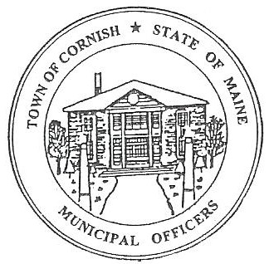
Town of Cornish
PLANNING BOARD
17 Maple Street
Cornish, Maine 04020
Telephone: 207.625.4324 Fax: 207.625.4416 E-mail: planningboard@cornishme.com

BUSINESS MEETING AGENDA
6:30 p.m.

Monday, October 2, 2023
- Call to Order:

- Adjustments/Additions to the Agenda:

- Communications Received/Sent:

A. Recommendations to have the agendas and minutes on the Cornish Town website.

- Review of Minutes:

A. 09-11-2023

- Old Business:

- Devon Libby – Ref. R02 – 010C – Wadsworth Road.
- Reschedule – Workshop on October 16, 2023, meeting.
- Historical Properties Guidelines Implementation.
- LUO - corrections.

- New Business:

- Miscellaneous:

- Public Comment:

- Agenda Items for Next Meeting: Workshop – Monday, October 16, 2023 @ 6:30 PM

- Adjournment

