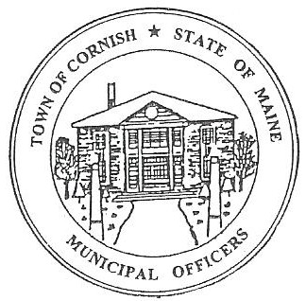
PLANNING BOARD
17 Maple Street
Cornish, Maine 04020
Telephone: 207.625.4324 Fax: 207.625.4416 E-mail: planningboard@cornishme.com

Monday, September 11, 2023
BUSINESS MEETING MINUTES
630PM
- Call to Order

Chairperson - Les MacMaster called the meeting to order at 6:33 p.m.

Present: Chair – Les MacMaster, Vice Chair- Eve Bergstrom, Secretary - M. Angel Eastman, Adam Craig, Bob Plourde, (Associate) - Nancy Perkins

Absent: Ryan Lane (Associate).

Guest: Joe Perry, John Bleakney, Jon Bailey, Dan Messer, Dan Vaillancourt

11. Adjustments/Additions to the Agenda:
111. Communication Received/Sent:
A. State of Maine Dept. of Economic And Community Development was approved. Funding of
$5,000.00 will be available for the Planning Board.
B. Historical Properties Guidelines have been passed at the Cornish Special Town Meeting on
August 23, 2023.
1V. Review of Minutes: Minutes were approved for 08-10-23.
V. Old Business:
1. Devon Libby- Ref. R02-010C- Wadsworth Road.
a. Has moved his meeting to October 2, 2023, business meeting.
2. Joe Perry-( ref -R01-002) – proposed campground.
a. Received a mailing address of 517 Maple Street Cornish Maine 04020.
. b. DOT has mandatory signs suggested to Joe Perry for his campground on Route 25 East
and West. He must maintain both signs.
c. Conditional Use Letter has been read. All planning Board members agreed.
and voted on. Next step for Joe Perry is to see the CEO for permits.
3. Alexander Berkeley has been using his residential parking lot for commercial use. Needs to
have a Change of Use Permit at this time.
a. Needs to come in with a plan on his intention moving forward.

V1. New Business
- Historical Properties Guidelines need clarification on the historical houses moving forward.

- Any spelling in the LUO share with Les and it will be presented in the annual Cornish Town Meeting.
V11. Miscellaneous:

V111. Public Comment:

1X. Agenda Items for Next Meeting: Workshop – Monday, September 18, 2023 @ 6:30 PM

X. Adjournment: 6:57 P.M.

Respectfully Submitted,
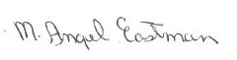
M. Angel Eastman
CPB Secretary
Approved at the October 2, 2023, Business Meeting.

