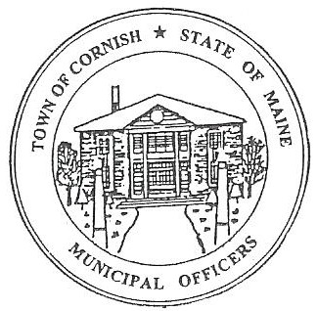
Town of Cornish
PLANNING BOARD
17 Maple Street
Cornish, Maine 04020
Telephone: 207.625.4324 Fax: 207.625.4416 E-mail:planningboard@cornishme.com

Business Meeting Agenda
6:30 p.m.

Monday,

August 7, 2023
- Call to Order:
- Adjustments/Additions to the Agenda:
- Communications Received/Sent:
- Historic Properties Guidelines.
- State of Maine Dept. of Economic And Community Development.
- Review of Minutes: 07-10-23.
- Old Business:
- Joe Perry – proposed campground (ref.-R01-002).
- New Business:
- Brooke Anderson- ref R02-076 (property owner Richard Taylor).
- Miscellaneous:
- Public Comment:
- Agenda Items for Next Meeting: Workshop – Monday, August 21, 2023 @ 6:30 PM
- Adjournment:

