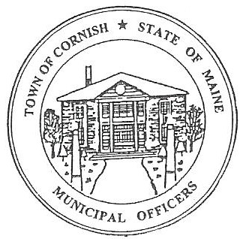
Town of Cornish
PLANNING BOARD
17 Maple Street
Cornish, Maine 04020
Telephone: 207.625.4324 Fax: 207.625.4416 E-mail:planningboard@cornishme.com

Business Meeting Agenda
6:30 p.m.

Monday, July 10, 2023
- Call to Order:
- Adjustments/Additions to the Agenda:
- Communications Received/Sent:
- Review of Minutes: 05-01-23
- Old Business:
- Adam Craig and Bob Plourde continuing research on recommendation from the lawyer on Historic Preservation Guidelines.
- Joe Perry – proposed campground (ref.-R01-002).
- New Business:
- Miscellaneous:
- Public Comment:
- Agenda Items for Next Meeting: Workshop – Monday, July 17, 2023 @ 6:30 PM
- Adjournment:

