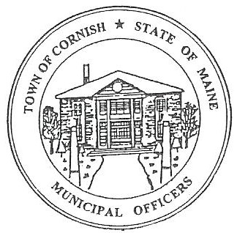
Town of Cornish
PLANNING BOARD
17 Maple Street
Cornish, Maine 04020
Telephone: 207.625.4324 Fax: 207.625.4416 E-mail: planningboard@cornishme.com

BUSINESS MEETING AGENDA
6:30 p.m.

Monday, Sept 11, 2023
- Call to Order

- Adjustments/Additions to the Agenda

- Communications Received/Sent:

A Cornish Historic Properties Guidelines
- On August 23, 2023, at the Cornish Special Town meeting the guidelines were passed by registered voters of Cornish.

B. Michael and Lisa Fulginiti (ref.- U03 - 044).
1. A parking lot that has been put in by the Cottage House (ref. U03-041) – 6 High Rd.
a. Claiming it is a nuisance and an eyesore.
b. Was not notified in writing of the changed use of a Conditional Use Permit.
c. Has been invited to the workshop meeting on September 18, 2023.

- Review of Minutes: 08-07-23

- Old Business:

- Devon Libby - ref (R02-010C) - Wadsworth Lane.
- Joe Perry – ref (R01-002) proposed campground.

- New Business

- Miscellaneous

- Public Comment

- Agenda Items for Next Meeting: Workshop – Monday, September 18, 2023 @ 6:30 PM

- Adjournment

