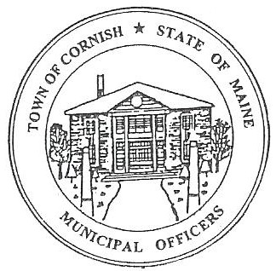
PLANNING BOARD
17 Maple Street
Cornish, Maine 04020
Telephone: 207.625.4324 Fax: 207.625.4416 E-mail: planningboard@cornishme.com

Monday, August 7, 2023
BUSINESS MEETING MINUTES
630PM
- Call to Order

Chairperson - Les MacMaster called the meeting to order at 6:30 p.m.

Present: Chair – Les MacMaster, Vice Chair- Eve Bergstrom, Secretary - M. Angel Eastman, Adam Craig, Bob Plourde, (Associates) - Nancy Perkins and Ryan Lane.

Absent: None

Guest: Joe Perry, Devon Libby

11. Adjustments/Additions to the Agenda:
111. Communication Received/Sent:
A. State of Maine Dept. of Economic and Community Development.
1. Town Deputy Clerk (Monique Guptill) will fill out the paperwork to get on the list for
Funding.
1V. Review of Minutes: Approved minutes from 07-10-23
V. Old Business:
1. Devon Libby- Ref. R02-010C- Wadsworth Lane.
a. Most everything done that is required by The Planning Board.
b. Water testing must be done yearly because of the location of the water runoff.
c. Workshop meeting August 21, 2023.
2. Joe Perry-( ref -R01-002) – proposed campground.
a. Handed out the updated layout.
b. Joe Perry had an idea for a sign that will hopefully slow the traffic down on route 25
approaching the campground.
c. Start with DOT first to see if they will put up signs.
d. Site walk review. Thursday August 24, 2023, at 530 PM.
V1. New Business
V11. Miscellaneous:

V111. Public Comment:

1X. Agenda Items for Next Meeting: Workshop – Monday, August 21, 2023 @ 6:30 PM

X. Adjournment: 7:05 P.M.

Respectfully Submitted,
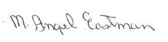
M. Angel Eastman
CPB Secretary
Approved at the September 11, 2023, business meeting.

