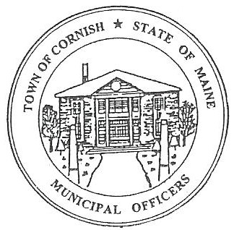
PLANNING BOARD
17 Maple Street
Cornish, Maine 04020
Telephone: 207.625.4324 Fax: 207.625.4416 E-mail: planningboard@cornishme.com

Monday, July 10, 2023
BUSINESS MEETING MINUTES

- Call to Order

Chairperson - Les MacMaster called the meeting to order at 6:32 p.m.

Present: Chair – Les MacMaster, Vice Chair- Eve Bergstrom, Secretary - M. Angel Eastman, Bob Plourde, (Associates) - Nancy Perkins and Ryan Lane.

Absent: Adam Craig.

Guest: Code Enforcer Officer -Dan Vaillancourt, Selectboard- Jess Larson, Joe Perry
Holly Higgins, Diann Perkins.

Adjustments/Additions to the Agenda:

- Communication Received/Sent:

- Review of Minutes: Approved minutes from 06-05-23

- Old Business:

      - Bob Plourde – Reviewed his findings on the Historical Properties Committee of Cornish – Proposed Guidance. With corrections the Planning Board voted yes to proposed guidance pertaining to Historic
Properties and the Historic District in Cornish.
      - James Carr – (ref R02-007) CEO – Dan Vaillancourt sent a letter reminding James Carr of his water testing on the property of Cornish Storage Unites. No response yet.
      - Joe Perry – (ref. R01-002)
        - Updated the Planning Board on his progress on the clearing of debris on the campground.
        - Mentioned the entrance that DOT has approved. (Had to raise the the entrance for approval). The planning Board still has concerns for the safety of entering and exiting of the entrance. There was a lengthy discussion, but no decisions were made at this time.
        - Site Plan Review on July 17, 2023.

- New Business

- Miscellaneous:

- Public Comments

      - Diann Perkins had concerns about the Cornish Storage Units. She was told James Carr can have them on his private property but cannot rent them out for his business until approved by CEO or the Planning Board.
      - Jess Larson announced that the Cell Tower grant was making progress into the next step of it processing.

- Agenda Items for Next Meeting: Workshop – Monday, July 17, 2023 @ 6:30 PM

- Adjournment: 7:24 P.M.

Respectfully Submitted,
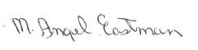
M. Angel Eastman
CPB Secretary
Approved on August 7, 2023, Business Meeting

