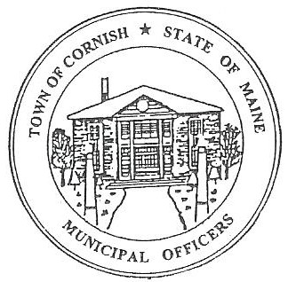
PLANNING BOARD
17 Maple Street
Cornish, Maine 04020
Telephone: 207.625.4324 Fax: 207.625.4416 E-mail: planningboard@cornishme.com

Monday, May 1, 2023
BUSINESS MEETING MINUTES

- Call to Order

Chairperson Les MacMaster called the meeting to order at 6:32 p.m.

Present: Chair – Les MacMaster, Vice Chair- Eve Bergstrom, Adam Craig, Secretary - M. Angel Eastman

Absent: Nancy Perkins (Associate), Bob Plourde

Guest: Code Enforcer Officer -Dan Vaillancourt, Selectboard- Jess Larson, David Hall,
Alexander Berkeley.

Adjustments/Additions to the Agenda:

- Communication Received/Sent:

- Review of Minutes: Minutes (04 -03 -23) approved.

- Old Business:
      - Devon Libby - (R02-010C) moved to May 15, 2023, workshop.
      - David Hall withdrew from being a candidate for the Planning Board Associate.
      - Ryan Lane, a candidate for the Planning Board Associate did not attend.
      - The Planning Board heard from lawyer relating to the Historical Properties Committee Guidelines.
        - Adam Craig – Doing research on Saco Historic Preservation Guidelines.
        - Bob Plourde – Doing research on Dept. of Interior U.S. Historic Preservation Guidelines.
      - New updated town map (12 – 23 – 22) – signed and embossed with the Town of Cornish seal.
      - Zackery Hayes- Cuttin’ Above Barber Company
        - Conditional Use Permit covers all town permits.
        - Needs to purchase a Business permit from the Town of Cornish.

- New Business:

      - Alexander Berkeley
        - Was discussing plans for the Cornish Inn.
        - The CEO (Dan Vaillancourt) let Alexander Berkeley know he needs to have a business plan to expand. (Barn, parking, cottage house, etc.....).

- Miscellaneous:

- Public Comment:

- Agenda Items for Next Meeting: Workshop – Monday, May 15, 2023 @ 6:30 PM

- Adjournment: 7:14 P.M.

Respectfully Submitted,
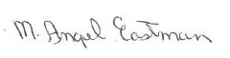
M. Angel Eastman
CPB Secretary
Approve June 5, 2023, business meeting

