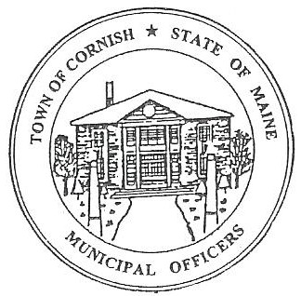
Town of Cornish
PLANNING BOARD
17 Maple Street
Cornish, Maine 04020
Telephone: 207.625.4324 Fax: 207.625.4416 E-mail: planningboard@cornishme.com

WORKSHOP MEETING AGENDA
6:30 p.m.

Monday, April 17, 2023

- Call to Order

- Adjustments/Additions to the Agenda:

- Tabled Devon Libby
- Saco River Commission – Joe Perry- permit-#08-018
- Historical Properties Committee of Cornish – Still no word from lawyers
- Updated roster for Planning Board Members

- Communications Received/Sent

- Review Minutes: 04-03-23-BM

- Old Business:

- Zackery Hayes- Cuttin’ Above Barber Company.
- Devon Libby – R02-010C - Wadsworth Lane

- New Business

- Miscellaneous

- Public Comment

- Agenda Items for Next Meeting: Business – Monday, May 1, 2023 @ 6:30 PM

- Adjournment

