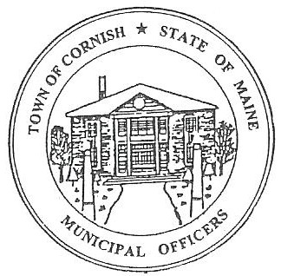
PLANNING BOARD
17 Maple Street
Cornish, Maine 04020
Telephone: 207.625.4324 Fax: 207.625.4416 E-mail: planningboard@cornishme.com

Monday, April 3, 2023
BUSINESS MEETING MINUTES

- Call to Order

Chairperson - Les MacMaster called the meeting to order at 6:34 p.m.

Present: Chair – Les MacMaster, Vice Chair- Eve Bergstrom Secretary -M. Angel Eastman, Adam Craig, (Associate) Nancy Perkins.

Absent: Bob Plourde

Guest: CEO- Dan Vaillancourt, Devon Libby

Adjustments/Additions to the Agenda:

- Communication Received/Sent:

        - People responding to the Associate opening on the Planning Board.
- Ryan Lane
- David Hall

- Review of Minutes: 03-06-23 - approved.

- Old Business:

- New Business:

      - Election of Officers:
        - Chairman – Les MacMaster
        - Vice Chairman – Eve Bergstrom
        - Secretary – M. Angel Eastman
      - Zackery Hayes –U-06/009 -185 Main Street - Cuttin’ Above Barber Company – Workshop April 17, 2023
      - Devon Libby - -R02-010C - Wadsworth Lane
        - Building a garage (50 feet x 80 feet) for a maintenance facility
        - Pre – Application Review - Workshop April 17, 2023

- Miscellaneous:

- Public Comment:

- Agenda Items for Next Meeting: Workshop – Monday, April 17, 2023 @ 6:30 P.M.

- Adjournment: 6:56 p.m.

Respectfully Submitted,
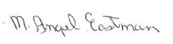
M Angel Eastman
CPB Secretary

