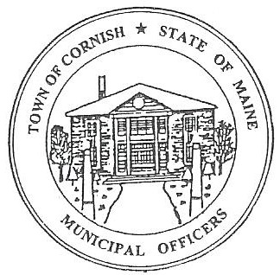
PLANNING BOARD
17 Maple Street
Cornish, Maine 04020
Telephone: 207.625.4324 Fax: 207.625.4416 E-mail: planningboard@cornishme.com

Monday, June 6, 2022
BUSINESS MEETING MINUTES

I. Call to Order

Chairmen – Les MacMaster called the meeting to order at 6:30 p.m.

Present: Chairman -Les MacMaster, Vice Chair- Eve Bergstrom, Secretary - Angel Eastman, Ken Hall, Bob Plourde, Adam Craig (Alternate).

Absent: Nancy Perkin (Alternate).

Guests Present: CEO- Dan Vaillancourt, Selectboard - Jess Larson

II. Adjustments/Additions to the Agenda: None

III. Communication Received/Sent:

a. Jess Larson talked about the ongoing update of the cell tower.
b. CEO - Dan Vaillancourt requested a letter be sent to Debra Furlong stating that she does not have to come in front of the planning board again on R08-39B.

IV. Review of Minutes: January 3,2022 BM, February 7, 2022, BM, March 7, 2022, BM, April 4, 2022, BM, April 20, 2022, WM.
- Motion made by Eve Bergstrom. 2nd by M. Angel Eastman. All the planning board approved.

V. Old Business:

a. Les MacMaster had a phone conversation referring R02-077 (James Carr)
Cornish Drive- In Storage expansion. Reminded him after the site fees are paid, he has 18 months to begin. With the prices of steel, he has decided to wait.

VI. New Business:

- Vasileios (Billy)and Christos Anastasiadis – U02-002. Expansion on the Dollar Store.
- Needs to do a pre- application- Add on 2000 feet on the eye doctor’s side. Take out six parking spaces add 15 parking places. Total over all of building 12,500. The building right now is 10,500. Possibly an office.
- Next workshop meeting June 20, 2022.

VII. Miscellaneous: None

VIII. Public Comment: None

IX. Agenda Items for Next Meeting: Workshop – Monday, June 20, 2022 @ 6:30 PM

X. Adjournment:

Les MacMaster made a motion to adjourn the business meeting at 7:36 p.m. It was seconded by Ken Hall. Motion carried with all in favor.

Respectfully Submitted,
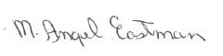

M. Angel Eastman
CPB Secretary
Approved at the July 18, 2022 meeting

