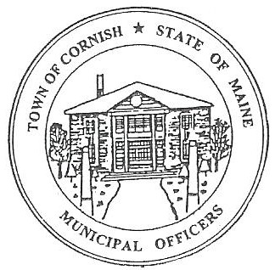
Town of Cornish
PLANNING BOARD
17 Maple Street
Cornish, Maine 04020
Telephone: 207.625.4324 Fax: 207.625.4416 E-mail: planningboard@cornishme.com

Business Meeting Agenda
6:30 p.m.

Monday, August 1, 2022
- Call to Order:
- Adjustments/Additions to the Agenda:
- Communications Received/Sent:
- Review of Minutes: (review of minutes of July 18, 2022)
- Old Business:
None
- New Business
- Town of Cornish Industrial Park - Robert Libby
- Line issues: R2-64, R2-64-4
- Miscellaneous:
- Public Comment:
- Agenda Items for Next Meeting: Workshop – Monday, August 15, 2022 @ 6:30 PM
a.
- Adjournment

