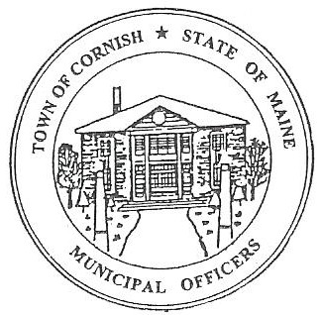
Town of Cornish
PLANNING BOARD
17 Maple Street
Cornish, Maine 04020
Telephone: 207.625.4324 Fax: 207.625.4416 E-mail: planningboard@cornishme.com

BUSINESS MEETING AGENDA
6:30 p.m.

Monday, April 4, 2022
- Call to Order

- Adjustments/Additions to the Agenda

- Communications Received/Sent

- Review of Minutes

- Old Business

None

- New Business
- Elect Chair
- Elect Vice Chair

- Miscellaneous

- Public Comment

- Agenda Items for Next Meeting: Workshop – Monday, April 18, 2022 @ 6:30 PM

- Adjournment

