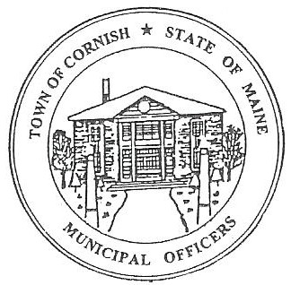
PLANNING BOARD
17 Maple Street
Cornish, Maine 04020
Telephone: 207.625.4324 Fax: 207.625.4416 E-mail: planningboard@cornishme.com

Monday, July 18, 2022
BUSINESS MEETING MINUTES

- Call to Order

Chairperson - Les MacMaster called the meeting to order at 6:30 p.m.

Present: Chair – Les MacMaster, Vice Chair- Eve Bergstrom, Ken Hall, Bob Plourde, two alternates, Nancy Perkins, Adam Craig, Recorder- M. Angel Eastman

Absent: none

Guest: Diann W. Perkins and Nancy Perkins of The Cornish Historic Committee

Adjustments/Additions to the Agenda: The Cornish Historic Committee

- Communication Received/Sent:

  - Classes for Planning Board Members August 25, 2022. Members Adam Craig, Les MacMaster, and CEO - Dan Vaillancourt please contact Town Clerk - Monique Guptill

- Review of Minutes: 06/18/2022 approved as read

- Old Business:

a. Maps – Eve Bergstrom explains the difference in the two maps (tax, zoning). Funds are not there currently. Solution wait for income fees.

- New Business:

  - Change September meetings. Same place, same time (approved)
  - Tuesday September 6, 2022 (business).
  - Monday September 19, 2022 (workshop)
  - Eve Bergstrom term is up on the board. She has decided to take her oath again for three years.
  - Ken Hall term is up on the board. He has decided to drop down as an alternate and will take his oath with no stipend.
  - Adam Craig will step up from an alternate to take his oath as a board member for the next three years.
  - Diann W. Perkins has been elected by the Planning Board as a subcommittee to preserve the historic buildings and architectural. A letter was submitted but a new letter and name needs to be resubmitted to the Planning Board before giving to the public.

- Miscellaneous: none

- Public Comment: none

- Agenda Items for Next Meeting: Workshop – Monday, August 15, 2022 @ 6:30 PM

- Adjournment:
  - Eve Bergstrom made a motion to adjourn the business meeting at 7:28 p.m. It was seconded by Angel Eastman. Motion carried with all in favor.

Respectfully Submitted,
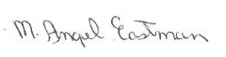
M Angel Eastman
CPB Secretary
Approved at the August 1, 2022 meeting

