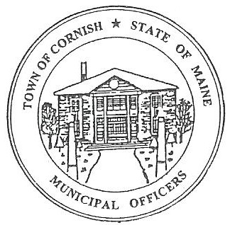
Town of Cornish
PLANNING BOARD
17 Maple Street
Cornish, Maine 04020
Telephone: 207.625.4324 Fax: 207.625.4416 E-mail: planningboard@cornishme.com

BUSINESS MEETING AGENDA
6:30 p.m.

Monday, June 6, 2022
- Call to Order
- Adjustments/Additions to the Agenda
- Communications Received/Sent
- Review of Minutes
(January 1, 2022 BM, March 7, 2022 BM, April 4, 2022 BM)
- Old Business
- R02-077 – Cornish Drive-In Storage Expansion
- New Business
- U02-002 Vasileios (Billy) and Christos Anastasiadis Building Expansion Overview
- Miscellaneous
- Public Comment
- Agenda Items for Next Meeting: Workshop – Monday, June 20, 2022 @ 6:30 PM
- LD2003 Discussion
- Adjournment

