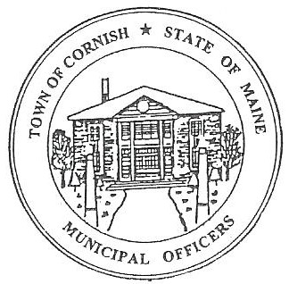
Town of Cornish
PLANNING BOARD
17 Maple Street
Cornish, Maine 04020
Telephone: 207.625.4324 Fax: 207.625.4416 E-mail: planningboard@cornishme.com

BUSINESS MEETING AGENDA
6:30 p.m.

Monday, March 7, 2022
- Call to Order

- Adjustments/Additions to the Agenda

- Pre-application – Subdivision Review – Michael Jordan – Old High Rd – Map R01, Lot 029B

- Communications Received/Sent

- Review of Minutes
(October, 4, 2021 BM, October 18, 2021 WS, November 1, 2021 BM, November 15, 2021 WS)

- Old Business

None

- New Business

- Carol Murphy, CEO Sacopee Valley Health Center – Proposed Walk-In Clinic at Call’s Plaza – Map R01, Lot 016A

- Miscellaneous

- Public Comment

- Agenda Items for Next Meeting: Business – Monday, April 4, 2022 @ 6:30 PM

- Reminder: No Workshop Meeting in March due to Annual Town Meeting
- Reminder: Public Informational Saturday, March 19, 2022 @ 10:00 a.m.

- Adjournment

