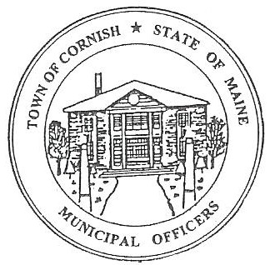
Town of Cornish
PLANNING BOARD
17 Maple Street
Cornish, Maine 04020
Telephone: 207.625.4324 Fax: 207.625.4416 E-mail: planningboard@cornishme.com

BUSINESS MEETING AGENDA
6:30 p.m.

Monday, January 3, 2022
- Call to Order

- Adjustments/Additions to the Agenda

- Communications Received/Sent

- Review of Minutes

- Old Business

None

- New Business

- Carol Murphy, CEO Sacopee Valley Health Center – Proposed Walk-In Clinic at Call’s Plaza – Map R01, Lot 016A

- Miscellaneous

- Public Comment

- Agenda Items for Next Meeting: Workshop – Monday, February 21, 2022 @ 6:30 PM

- February 21, 2022 workshop meeting includes Public Informational Meeting for LUO.

- Adjournment

