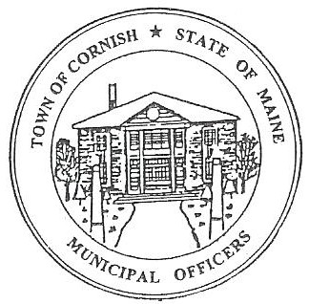
Town of Cornish
PLANNING BOARD
17 Maple Street
Cornish, Maine 04020
Telephone: 207.625.4324 Fax: 207.625.4416 E-mail: planningboard@cornishme.com

WORKSHOP MEETING AGENDA
6:30 p.m.

Monday, February 21, 2022

- Call to Order

- Public Informational Meeting – Land Use Ordinance Revisions

- Communications Received/Sent

- Old Business

- New Business

- Miscellaneous

- Public Comment

- Agenda Items for Next Meeting: Business – Monday, March 7, 2022 @ 6:30 PM

- Reminder: No Workshop Meeting in March due to Annual Town Meeting
- Reminder: Public Informational Saturday, March 19, 2022 @ 10:00 a.m.

- Adjournment

