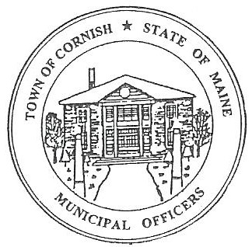
Town of Cornish
PLANNING BOARD
17 Maple Street
Cornish, Maine 04020
Telephone: 207.625.4324 Fax: 207.625.4416 E-mail: planningboard@cornishme.com

BUSINESS MEETING AGENDA
6:30 p.m.

Monday, January 3, 2022

- Call to Order

- Adjustments/Additions to the Agenda

- Communications Received/Sent

- Review of Minutes

- Old Business

- Land Use Ordinance Review

- New Business

None
- Miscellaneous

- Public Comment

- Agenda Items for Next Meeting: Business – Monday, February 7, 2022 @ 6:30 PM

- Reminder no workshop in January due to the holiday.
- February 21, 2022 workshop meeting includes Informational Meeting for LUO.

- Adjournment

