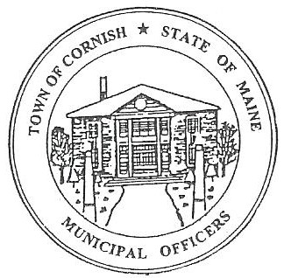
Town of Cornish
PLANNING BOARD
17 Maple Street
Cornish, Maine 04020
Telephone: 207.625.4324 Fax: 207.625.4416 E-mail: planningboard@cornishme.com

Monday, June 15, 2020
WORKSHOP MEETING MINUTES
Call to Order

Chairwoman Jessica Larson called the meeting to order at 6:30 p.m.

Present: Jessica Larson, Eve Bergstrom, Angel Eastman, Ken Hall, Sandra Watts

Absent: Erica Craig, Nancy Perkins

Guests Present: John Watts,

Old Business:

- SMPDC – Review of Land Use Ordinances

The Board completed the review of the amendments to the Land Use Ordinances that Abby Sherwin of Southern Maine Planning and Development has made. The Board discussed the best way to present the amendments to the Town at a Special Town Meeting as well as how to present the Solar Energy Systems Ordinance. There are no dates yet for Town Meeting or a Special Town Meeting due to COVID-19 and limitations on gatherings.

(NOTE: All documentation regarding the updated Land Use Ordinance can be found in the Planning Board Ordinance file.)

Adjournment

Angel Eastman made a motion to adjourn the business meeting at 7:45 p.m. It was seconded by Eve Bergstrom. Motion carried with all in favor.

Respectfully Submitted,
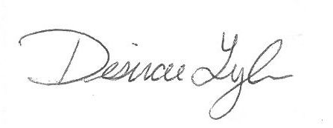
Desirae Lyle
CPB Secretary

