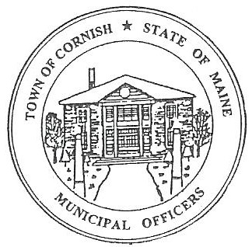
PLANNING BOARD
17 Maple Street
Cornish, Maine 04020
Telephone: 207.625.4324 Fax: 207.625.4416 E-mail: planningboard@cornishme.com

Monday, September 16, 2019
WORKSHOP MEETING MINUTES
Call to Order

Chairwoman Jessica Larson called the meeting to order at 6:32 p.m.

Present: Jessica Larson, Eve Bergstrom, Angel Eastman, Nancy Perkins, Sandra Watts, Code Enforcement Officer Wes Sunderland Recorder Desirae Lyle.

Absent: Ken Hall

Guests Present: Abby Sherwin, Diann Perkins, John Watts

New Business:

- Mike Jordan – Jordan Harvesting – 688 S. Hiram Rd – U01-006

Mr. Jordan was not present at tonight’s meeting; therefore this agenda item was not discussed.

- Southern Maine Planning and Development Commission – Abby Sherwin

The Board and Abby Sherwin extensively reviewed the edits that she provided.

The Board thoroughly discussed and read through the subdivision ordinance.

- Correspondence: None

Adjournment:

Erica Craig made a motion to adjourn the workshop meeting at 8:10 p.m. It was seconded by Eve Bergstrom. Motion carried with all in favor.

Respectfully Submitted,
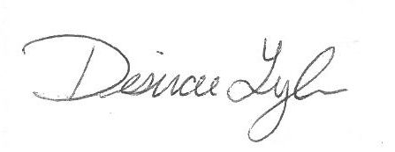
Desirae Lyle
CPB Secretary

