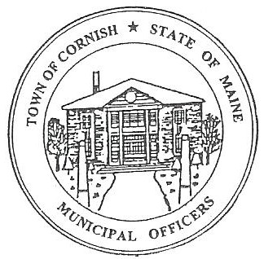
PLANNING BOARD
17 Maple Street
Cornish, Maine 04020
Telephone: 207.625.4324 Fax: 207.625.4416 E-mail: planningboard@cornishme.com

Monday, August 19, 2019
WORKSHOP MEETING MINUTES
Call to Order

Chairwoman Jessica Larson called the meeting to order at 6:22 p.m.

Present: Jessica Larson, Eve Bergstrom, Erica Craig, Angel Eastman, Ken Hall, Nancy Perkins, Sandra Watts, Code Enforcement Officer Wes Sunderland Recorder Desirae Lyle.

Guests Present: Diann Perkins, John Watts

New Business:

- Correspondence

- Jess has posted in the notice section of Your Weekly Shopping Guide that because of the Labor Day holiday the September 2, 2019 meeting has been moved to September 9, 2019.

- Erica Craig will be enrolled in the Maine Municipal Association Planning/Appeals Board workshop in Augusta on December 5, 2019.

- Angel Eastman, Jess Larson and Nancy Perkins will be attending the Maine Municipal Association Legal Update on Recreational Marijuana Workshop this Wednesday August 21, 2019 in Saco.

- Eve Bergstrom has been in touch with the Maine GeoLibrary concerning digitizing the town maps. (The email correspondence will be included with the original set of these minutes.) The cost will need to be addressed as well as the fact that the town does not have the software.

- Angel Eastman attended the MMA Planning/Appeals Board workshop in Bethel on July 30, 2019. Angel found the workshop informative and helpful.

- Jess Larson attended a recent Selectmen’s meeting, and entertainment permits were discussed. Licensing is required through the State Fire Marshal’s Office. When a restaurant gets a license the Fire Marshal’s office is notified and inspects the location. Bars with live entertainment, dance halls etc., needs a live entertainment license

Upon searching the State Fire Marshal’s website Desirae Lyle found a Dance Hall permit for Fairgrounds Restaurant that expired on July 31, 2019.

- Erica Craig read aloud the second paragraph of a letter from Saco River Corridor Commission. (This letter will be included with the original set of these minutes.) These rules are now legally effective within the Saco River Corridor which includes all areas up to 500 feet from the normal or mean high water line of the Saco, Ossipee and Little Ossipee Rivers. The Commissions jurisdiction extends up to 1,000 feet from the normal or mean high water line of the rivers in areas of the 100 year floodplain or 1 percent chance of annual flood. Any property being developed that is within 500 feet of the rivers needs to go before the Saco River Corridor Commission before it can be approved through the Town.

- Cornish By-Laws

Eve Bergstrom read aloud from the by-laws Article I - Establishment - Pursuant to Art. VIII, Pt. 2, Sec. 1 of the Maine Constitution and 30-A M.R.S.A. § 3001, the Town of Cornish hereby established a planning board at the 2009 Cornish Annual Town Meeting. The board, which has been acting as a planning board for the Town of Cornish, is hereby reestablished as the legal planning board for the purposes of this ordinance. The actions which the board took prior to the adoption of this ordinance are hereby declared to be the acts of the legally constituted planning board of the Town of Cornish.
Angel Eastman read Article IV, Section 1B. Planning Board - The Planning Board shall be responsible for reviewing and acting upon applications for Site Plan Review Approval and uses requiring building or use permits from the Planning Board.
At the March 16, 2009 Town Meeting, that ordinance was approved, the ordinance was approved but never included in the Land Use Ordinance. The establishment of the Planning Board needs to be incorporated to the Land Use Ordinances as an appendix. Anything in the Bylaws that doesn’t have to do with the ordinances can be changed and updated, so the ordinance sections in the bylaws need to be removed. Jess will let Abby Sherwin from Southern Maine Planning and Development Commission know that this needs to be added to the ordinances.
Adjournment:

Erica Craig made a motion to adjourn the business meeting at 7:05 p.m. It was seconded by Angel Eastman. Motion carried with all in favor.

Respectfully Submitted,
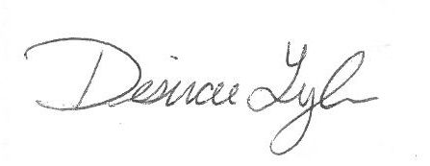
Desirae Lyle
CPB Secretary

