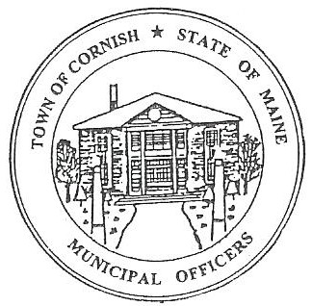
PLANNING BOARD
17 Maple Street
Cornish, Maine 04020
Telephone: 207.625.4324 Fax: 207.625.4416 E-mail: planningboard@cornishme.com

Monday, July 15, 2019
WORKSHOP MEETING MINUTES

Call to Order

Chairwoman Jessica Larson called the meeting to order at 6:30 p.m.

Present: Jessica Larson, Eve Bergstrom, Erica Craig, Angel Eastman, Ken Hall, Sandra Watts, Code Enforcement Officer Wes Sunderland Recorder Desirae Bachelder.

Absent: Nancy Perkins

Guests Present: John Watts

New Business:

- Michael Jordan – Jordan Tree Harvesters Inc. – U01-006

The applicant was absent from this meeting therefore this agenda item was not discussed.

- Dan Vaillancourt – Historic District Permit

Dan Vaillancourt is here for guidance, he has been contracted to build a 20 by 24 foot deck behind Lily’s flower shop at 18 Main Street. There was a barn there years ago so there is still a foundation, the only change being that they would like to extend the deck four (4) feet so that the vehicles can be parked underneath the deck.

Map U03 Lot 006 is on the list of Historic Buildings which needs Planning Board approval before any permits can be issued. Angel Eastman read aloud Article II, Section 6 (J) Historic Buildings: Approval is required from the Planning Board before the Code Enforcement Officer can issue a permit to demolish, move or alter the exterior elevations of a designated historic building (see Appendix C for a list of designated historic buildings and locations).

Jess recommended that Mr. Vaillancourt check the setback requirements for the Historic District. Jess also told Mr. Vaillancourt that Lily’s is not on the Town sewer system, she has her own septic tank and is not on the Town Sewer System, something to keep in mind if and when they can build the deck. The Board asked that Mr. Vaillancourt submit a site plan for the scope of work that will be done.

- Correspondence

  - Angel Eastman will be attending the Maine Municipal Association Planning/Zoning Board of Appeals Workshop on July 30, 2019 in Bethel.

  - Angel Eastman, Jess Larson and Nancy Perkins will be attending the Maine Municipal Association Legal Update on Recreational Marijuana Workshop on August 21, 2019 in Saco.

  - Jess received a call about an Air BnB; she referred the caller to Code Enforcement Officer Wes Sunderland. The Planning Board handles Bed & Breakfasts not Air B&B’s. There is one Air B&B in Town at this time.

- Miscellaneous

  - Diann Perkins had some concerns about the color of the sign at the Inn at Cornish. Since the Historic District Guidelines were never approved there is nothing the Board can do. But the color of the sign is in character with the Historic District. The Board would only be involved with the color or signs when a new Conditional Use Permit is brought before the Board.

  - Jess is going to follow up with Diane Harrington or Monique Guptill about getting the Planning Board signed up to receive Southern Maine Planning and Development updates and newsletters.

  - Eve Bergstrom and Jess Larson attended the Saco River Corridor Commission (SRCC) mapping session this morning. They both found the session very informative. Eve explained that the purpose behind the meeting is that the SRCC is updating their maps that show SRCC’s jurisdiction and uploading them to their website. Eve explained that Shoreland Zoning extends 250 feet from the waters edge, but the SRCC extends to 500 feet from the water’s edge. Jess explained further that development of any kind on the Saco or Ossipee Rivers within 500 feet of the water’s edge needs to go before the SRCC for approval. Jess also noted that no residential homes are allowed on the Resource Protection by SRCC. SRCC is strict about this because the drinking water supply for Biddeford and Saco comes from the Saco and Ossipee Rivers. Jess suggested that the ordinances need to be updated to advise applicants to go before the SRCC if they are within 500 feet of the Saco or Ossipee River water’s edge.

- Southern Maine Planning and Development – Abby Sherwin

Abbie Sherwin was not present at tonight’s meeting therefore this agenda item was not discussed.

Adjournment:

Eve Bergstrom made a motion to adjourn the business meeting at 7:05 p.m. It was seconded by Angel Eastman. Motion carried with all in favor.

Respectfully Submitted,
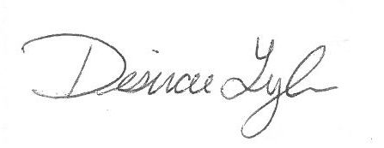
Desirae Lyle
CPB Secretary

