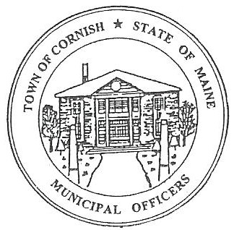
PLANNING BOARD
17 Maple Street
Cornish, Maine 04020
Telephone: 207.625.4324 Fax: 207.625.4416 E-mail: planningboard@cornishme.com

Monday, May 20, 2019
WORKSHOP MEETING MINUTES
Call to Order

Chairwoman Jessica Larson called the meeting to order at 6:31 p.m.

Present: Jessica Larson, Eve Bergstrom, Angel Eastman, Sandra Watts, Code Enforcement Officer Wes Sunderland Recorder Desirae Bachelder.

Absent: Erica Craig, Ken Hall, Nancy Perkins

Guests Present: Samantha Miller, Fred Hardy, Diann Perkins,

New Business:

- Miscellaneous – 48 Main St – U03-029

Samantha Miller and Fred Hardy explained that they would like to start a retail business at 48 Main Street, U03-029. The building is in the Village Center and Historic District Overlay and will require a Conditional Use Permit. Ms. Miller explained that they will not be moving in immediately, but will be doing some work to the property first. The plan is to live in the basement level and have the store in the middle level. They explained that it will be a retail business selling games, with a space in the back of the building for customers to try out games.

Jess Larson explained that the project will need a Conditional Use Permit also that a Social Club is prohibited in the Village Center and the Historic District Overlay. Events and gaming are fine as long as they do not become regularly scheduled social club events. Mr. Hardy explained that the “game room” would be available for customers who have purchased games and would like to try them out before they leave.

Angel Eastman read the definition for a Club, Social - : A group of people or the place they meet generally formed around a common interest, occupation, or activity. Such clubs and/or social clubs are welcome within the Town of Cornish; however, new clubs and/ or social clubs are prohibited from the districts of the Village Center and the Historic District overlay. For the purpose of this amendment, a church is not considered a social club.

Jess explained that since Ms. Miller’s grandmother owns the property they will need her to sign the Site Plan Review application because the property will be changing from residential to a retail business. Jess reminded Ms. Miller and Mr. Hardy that the property should be ADA compliant and they will need to address off street parking.

- Miscellaneous – Brent Anderson – 52 Maple St – U02-042

Jess Larson explained that this is a non-conforming lot with less than 20,000 square feet and a residence cannot be built on this property. The current footprint of the property must be adhered to.

- Southern Maine Planning Development Commission – Abbie Sherwin

The Board met with Abby Sherwin from Southern Maine Planning and Development concerning the revisions that she has been working on. Abby explained that she has been sending the Board only the pages with edits on them, so as not to overwhelm the Board.

Abby presented suggestions and changes to the current definitions and other sections of the ordinances. The Board discussed each of the revisions with Abby. She will make changes and send updates to the Board as necessary.

Communications Received/Sent:

- None

Adjournment:

Eve Bergstrom made a motion to adjourn the business meeting at 7:59 p.m. It was seconded by Angel Eastman. Motion carried with all in favor.

Respectfully Submitted,
Desirae Bachelder
CPB Secretary

