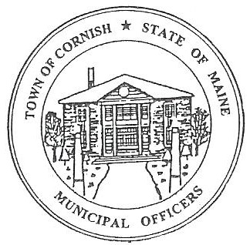
PLANNING BOARD
17 Maple Street
Cornish, Maine 04020
Telephone: 207.625.4324 Fax: 207.625.4416 E-mail: planningboard@cornishme.com

Monday, April 16, 2018
WORKSHOP MEETING MINUTES

Call to Order

Chairwoman Jessica Larson called the meeting to order at 7:18 p.m.

Present: Eve Bergstrom, Ken Hall, Jessica Larson, Emily Ward, Nancy Perkins, Sandra Watts, Code Enforcement Officer Wes Sunderland, Recorder Desirae Bachelder.

Absent: Norm Harding

Guests present: John Watts

New Business:

- Karen Remington – Approval letter

Jess Larson read aloud the letter to be sent to Karen Remington approving a list of items that she can sell on the premises of her Home Occupation, during class times only. The Board then signed the letter.

- Permission for Fire Weather Station on town owned property the Fairgrounds.

Jess Larson stated that another location for the station is at the Cornish Ball fields, by Metcalf’s Trading Post.

Nancy Perkins motioned that this item be tabled until a member of the Maine Forest Service can attend a meeting and explain all of the ins and outs of the Fire Weather Station. It was seconded by Jess Larson. Motion carried with all in favor.

- The Board discussed the proper procedure for items to come before the Planning Board. A pre-application meeting should be held, preferably at a workshop meeting to decide whether or not the applicant needs to come to a business meeting or if the applicant needs to meet with the Code Enforcement Officer. Any applicants should be directed to contact the Board via the planningboard@cornishme.com email. This way the applicant can be notified via email that they are on the agenda and attend the meetings.

If at the pre-application meeting the Conditional Use Permit application is deemed complete, a public hearing will be scheduled and abutter’s notices will be sent out.

- Jess Larson stated that she would like to change the Your Weekly Shopping Guide Notices section from “…contact Jessica Larson-Chair…” to “…contact via email planningboard@cornishme.com...” There were no objections to this change.

- Bay Haven

The Board discussed what was going on at Bay Haven Restaurant.

Nancy Perkins asked for clarification on who would be responsible for public safety concerning the propane tanks behind the restaurant. The last time she was there, there were only sawhorses blocking the tanks.

Emily Ward asked what was being done at Bay Haven and what had been permitted to be done.

CEO Wes Sunderland stated that the propane tanks are hazardous fuel that he has no authority over, they (Bay Haven) has to go through the State for any permits concerning the tanks. The saw horses have been replace recently.

The Board discussed the renovations/change of use of the enclosed decks.

Jess Larson asked Wes Sunderland to contact the Days and ask them to come to the next Planning Board meeting to talk with the Board and explain what they have done so far to the restaurant and the property.

Communications Received/Sent:

- MMA response (3/15/18) PB e-mail

Jess Larson stated that she had received a response from Maine Municipal Association Legal Department concerning the “Confidential Notice” statement at the end of the Planning Board email. The statement can be changed to a shorter statement.
- Rick Rowland (4/5/2018) PB e-mail

- Karen Remington (4/5/2018) PB e-mail

Public Comment:

Agenda Items for Next Meeting: Business Meeting – Monday, May 7, 2018 @ 6:30 PM
- Approve the minutes from the 4/16/2018 Business/Workshop Meeting.

Adjournment:

Ken Hall motioned to adjourn at 8:23 p.m. It was seconded by Emily Ward. Motion carried with all in favor.

Respectfully Submitted,
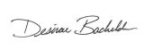
Desirae Bachelder
CPB Secretary

