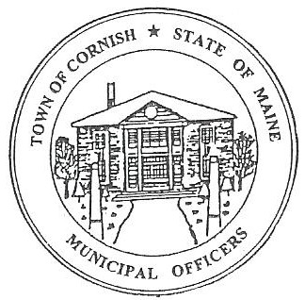
PLANNING BOARD
17 Maple Street
Cornish, Maine 04020
Telephone: 207.625.4324 Fax: 207.625.4416 E-mail: planningboard@cornishme.com

Monday, March 25, 2019
WORKSHOP MEETING MINUTES
Call to Order

Chairwoman Jessica Larson called the meeting to order at 6:30 p.m.

Present: Jessica Larson, Eve Bergstrom, Erica Craig, Nancy Perkins, Sandra Watts, Recorder Desirae Bachelder.

Absent: Angel Eastman, Ken Hall, Code Enforcement Officer Wes Sunderland

Guests Present: John Watts, Monique Guptill

New Business:

- Miscellaneous

- Ordinances

Jess Larson shared a new ordinance that was adopted at the March 18, 2019 Annual Town Meeting. A copy was given to Abby Sherwin to be added to the Land Use Ordinances. Jess also gave Abby a copy of the Headshop Ordinance that was adopted in April of 2017 that has not been added to the Land Use Ordinances.

- Workshop Invite
The Parsonsfield Planning Board has invited the surrounding Town’s planning boards to a workshop concerning a Medical Marijuana Ordinance. The workshop is on March 28, 2019 at 7:00 pm.

- SMPDC – Abby Sherwin

The Board met with Abby Sherwin from Southern Maine Planning and Development concerning the revised definitions that she has been working on. Abby presented suggestions and changes to the current definitions. The Board went through each of the definitions and discussed them with Abby for clarification. Abby will have a new draft for the Board for the next workshop she attends.

Communications Received/Sent:

- Reminder Site Walk 4/1/2019 at 4:00 pm
- Inn at Cornish Abutter’s Notices 43 Sent
- Inn at Cornish Ad in YWSG

Adjournment:

Nancy Perkins made a motion to adjourn the meeting at 8:30 p.m. It was seconded by Eve Bergstrom. Motion carried with all in favor.

Respectfully Submitted,
Desirae Bachelder
CPB Secretary

