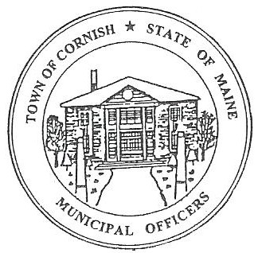
PLANNING BOARD
17 Maple Street
Cornish, Maine 04020
Telephone: 207.625.4324 Fax: 207.625.4416 E-mail: planningboard@cornishme.com

Monday, February 25, 2019
WORKSHOP MEETING MINUTES

Call to Order

Chairwoman Jessica Larson called the meeting to order at 6:31 p.m.

Present: Jessica Larson, Eve Bergstrom, Nancy Perkins, Sandra Watts, Code Enforcement Officer Wes Sunderland, Recorder Desirae Bachelder.

Absent: Ken Hall

Guests Present: Abby Sherwin – SMPDC, John Watts, Monique Guptill

New Business:

- Debra Furlong – Subdivision – R08-039B

The Board reviewed and signed the Conditional Use Permit Approval Letter for Ms. Furlong.

- Miscellaneous – The Inn at Cornish – Rick & Lori Rowland – U03-040

The Board has received the Site Plan Review application for the Inn at Cornish’s barn. The Rowlands will be on the agenda at the March 4, 2019 business meeting.

- Miscellaneous – Wadsworth Gravel Pit

Mr. Wadsworth has sold his property on Map R02, Lot 071. Wes will contact the new owners concerning the Reclamation Bond that is needed to continue operating the gravel pit.

- Southern Maine Planning and Development Commission

The board discussed with Abby Sherwin the scope of work and what Ms. Sherwin has begun working on. Ms. Sherwin will continue to send the Board updates as work is completed.

Communications Received/Sent:

None

Adjournment:

Nancy Perkins made a motion to adjourn the business meeting at 7:34 p.m. It was seconded by Eve Bergstrom. Motion carried with all in favor.

Respectfully Submitted,
Desirae Bachelder
CPB Secretary

