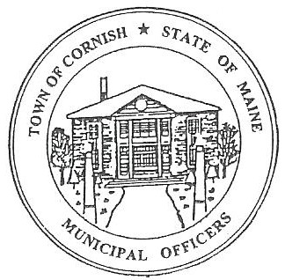
Town of Cornish
PLANNING BOARD
17 Maple Street
Cornish, Maine 04020
Telephone: 207.625.4324 Fax: 207.625.4416 E-mail: planningboard@cornishme.com

Monday, January 6, 2020
WORKSHOP MEETING MINUTES
Call to Order

Chairwoman Jessica Larson called the meeting to order at 6:30 p.m.

Present: Jessica Larson, Eve Bergstrom, Erica Craig, Angel Eastman, Ken Hall, Nancy Perkins, Sandra Watts, Code Enforcement Officer Wes Sunderland, Recorder Desirae Lyle.

Guests Present: John Watts, Diann Perkins

New Business:

- Approve Minutes from September 16, 2019 workshop, October 7, 2019 business meeting, November 4, 2019 business meeting, November 18, 2019 workshop meeting, December 2, 2019 business meeting.

Eve Bergstrom made a motion to approve the minutes from the September 16, 2019 workshop, October 7, 2019 business meeting, November 4, 2019 business meeting, and the November 18, 2019 workshop meeting. It was seconded by Erica Craig. Motion carried with all in favor.

The December 2, 2019 minutes are not available at this time.

- Correspondence

- There was an email from Elijah Wood concerning food trucks in Cornish. Jess Larson referred him to CEO, Wes Sunderland for more information.

- Town Clerk, Diane Harrington, sent an email regarding the Department of Agriculture’s Public Hearing concerning Hemp.

- Dalyn Houser of SRCC (Saco River Corridor Commission sent an email letting the town know that the new maps are on-line. The Board would like to invite Ms. Houser or someone from SRCC to a workshop to discuss and explain the new maps.

- Solar Power Discussion

The Board reviewed the proposed Solar Power Ordinance. Jess explained that regarding pole mounting she added line 4 to Dimensional Requirements: Pole Mounted Energy systems must comply with height restrictions of the district.

Nancy Perkins asked if in Section VII, B which states: Prior to operation, electrical connections must be inspected by the Code Enforcement Officer. Is the CEO required to have an electrical certification? Nancy suggested that the wording be changed to …inspected by a certified electrician or certified electrical inspector. The Board agreed that this sentence should be changed to: Prior to operation, electrical connections must be inspected by a licensed electrician.

Medium and large scale ground mounted solar power was discussed. Jess explained that medium and large scale would have to come before the Board with plans for a Conditional Use Permit. The plans would need to be drawn up by an electrical engineer.

Erica Craig made a motion to approve the Solar Power Ordinance with the changes made in Section B and send it to the Selectmen to be added to the Town Meeting Warrant for adoption. It was seconded by Angel Eastman. Motion carried with all in favor. Jess will send the updated ordinance to the Selectmen.

- MMA (Maine Municipal Association) Response

Angel Eastman read aloud the email response from MMA attorney Michael Stultz. (This email will be included with these minutes.)

Because of the changing laws, Jess would like to table further discussion of this topic until the next workshop meeting on January 20, 2020.

- Southern Maine Planning and Development Commission – Abby Sherwin

The Board explained to Ms. Sherwin that they will be using their upcoming workshops to confirm the updates that have been made to the Land Use Ordinances and compile a list of any questions or corrections that they may have for Ms. Sherwin.

Jess explained to Ms. Sherwin that if the Solar Ordinance is adopted at Town Meeting then in the Land Use Ordinance book Table 1 Table of Permissible Uses will need to be updated. Ms. Sherwin suggested putting this under “Commercial” uses.

Ms. Sherwin noted that the Board had asked that the State definition of a flag lot be included with the definitions, this definition does not exist and should be prohibited by dimensional requirements and road frontage requirements.

- Miscellaneous

Desirae mentioned that the next meeting January 20, 2020 is Martin Luther King Jr. day. The Board agreed to hold the meeting and not change the meeting date.

Adjournment

Angel Eastman made a motion to adjourn the business meeting at 7:50 p.m. It was seconded by Erica Craig. Motion carried with all in favor.

Respectfully Submitted,
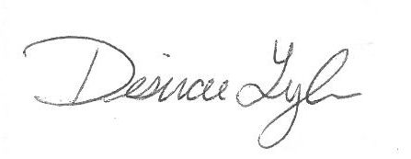
Desirae Lyle
CPB Secretary

