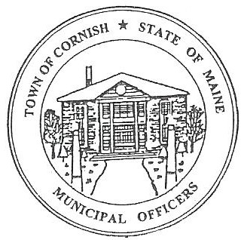
PLANNING BOARD
17 Maple Street
Cornish, Maine 04020
Telephone: 207.625.4324 Fax: 207.625.4416 E-mail: planningboard@cornishme.com

Monday, January 28, 2019
WORKSHOP MEETING MINUTES

Call to Order

Chairwoman Jessica Larson called the meeting to order at 6:28 p.m.

Present: Jessica Larson, Eve Bergstrom, Ken Hall, Emily Ward, Sandra Watts, Code Enforcement Officer Wes Sunderland, Recorder Desirae Bachelder.

Absent: Nancy Perkins

Guests Present: John Watts, Tom Dubois – Project Engineer, Debra Furlong, Denise Benton, Rick & Lori Rowland, Tiffany Parent

New Business:

- Miscellaneous – Board Resignation

Stephanie Smith has resigned from the planning board, the selectmen have been notified and the position will be advertised in the Your Weekly Shopping Guide.

- Miscellaneous – Fairgrounds Restaurant

After receiving the Conditional Use Permit Approval Letter, Mr. Anastasiadis has paid the remaining $400.00 due for the Site Plan Review Application.

- Miscellaneous – Budget Article

The new budget was approved by the Budget Committee las Thursday, January 24, 2019 and will be a warrant article at Annual Town Meeting.
- Debra Furlong – Subdivision – R08-039B

Tom Dubois presented a new plan and revised application. This is now a two lot, four unit subdivision. Lot 1 will be 3.8 acres with a duplex and a shed that is going to be moved because it is currently within the setback. Lot 2 will be 6.1 acres with a duplex and two sheds.

- Rick & Lori Rowland – Cornish Inn

Mr. Rowland would like to sell items in the office space of the Cornish Inn. Retail items are cover under Mr. Rowlands current Conditional Use Permit for the Inn. The barn was not included in the original CUP and will need a separate application for events to take place there.

Mr. Rowland also updated the Board on what improvements he has made to the Inn so far.

- Southern Maine Planning and Development Commission - Workshop Discussion

The Board met with Paul Schumacher of Southern Maine Planning and Development Commission to discuss moving forward with Land Use Ordinance updates and what parts of the ordinances the board feels needs attention.

The Board gave Mr. Schumacher some insight into what parts of the Ordinances really need to be looked at. Mr. Schumacher will pass this along to Abby Sherwin who will be working on the Cornish Ordinances.

Communications Received/Sent:

- Fairgrounds CUP letter
- COD Ad to YWSG

Adjournment:

Emily Ward made a motion to adjourn the workshop meeting at 7:46 p.m. It was seconded by Jess Larson. Motion carried with all in favor.

Respectfully Submitted,
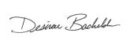
Desirae Bachelder
CPB Secretary

