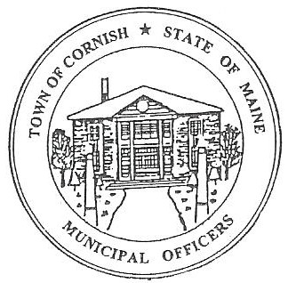
m Town of Cornish
PLANNING BOARD
17 Maple Street
Cornish, Maine 04020
Telephone: 207.625.4324 Fax: 207.625.4416 E-mail: planningboard@cornishme.com

Monday, January 20, 2020
WORKSHOP MEETING MINUTES
Call to Order

Chairwoman Jessica Larson called the meeting to order at 6:30 p.m.

Present: Jessica Larson, Eve Bergstrom, Erica Craig, Angel Eastman, Ken Hall, Nancy Perkins, Sandra Watts, Recorder Desirae Lyle.

Guests Present: John Watts

New Business:

- Correspondence

- There was an e-mail from Jim Roberts, CEO (Code Enforcement Officer) for the Town of Dayton, requesting the Solar Ordinance that the Board has recently approved. Jess sent a copy of the ordinance back to Mr. Roberts.

- Kelsey Pelton, of SMPDC (Southern Maine Planning and Development Commission), sent an email regarding a Solar Power workshop this Thursday, January 23, 2020 in Sanford. Jess Larson may be able to attend the meeting.

- Jess Larson reminded Desirae to send the payroll attendance roster to Town Clerk, Diane Harrington for processing as soon as possible.

- Wes Sunderland, CEO, left a request for a Pre-application meeting from Frank Baxter, 48 Maple St, Map U02, Lot 041. Mr. Baxter will be on the next meeting agenda which is Monday, February 3, 2020.

- Maine Municipal Association Response / Headshop Ordinance Discussion

The MMA response was regarding the Headshop Ordinance. Jess Larson read the last line of the email. (NOTE: This email will be included with these minutes.) When, then, the town revises, if it revises its ordinance, the ordinance needs to be consistent with the operation of Maine law generally as to how you treat stores that sell paraphernalia. Also keep in mind that were you to suspect a retail establishment supporting activities in violation of Maine’s criminal laws, you should contact law enforcement and the district attorney. Jess suggested leaving this ordinance alone until the State has updated the laws.

Jess mentioned Jodi David and Bad Frogz Budz. Initially Mr. David started out as a dispensary. Jess feels that Mr. David is now advertising as a medical marijuana storefront. Mr. David’s advertising has changed from what he originally presented to the Board. His establishment has not been approved as a retail store, and the Headshop Ordinance does not allow retail headshops outside of the Commercial District. The advertisement is very questionable. Headshops are not allowed in the Agricultural District. Jess will ask Wes to look into this.

- Budget Discussion

Jess Larson advised that the Selectmen approved $750.00 instead of the planned $2,000.00 that the Board requested to complete the Land Use Ordinance updates being done by SMPDC.

- Miscellaneous

Jess asked Desirae about the procedure for creating the Town Meeting Warrant Articles. Desirae explained that the Town Manager in Sebago creates the articles and the Selectmen and Budget Committee then approve them. Desirae looked up and read the articles from when Sebago last adopted ordinances. Jess will look into creating the article to adopt the Solar Power Ordinance and talk to the Town Clerk again.

- Ordinance Update Review

The Board read through pages 8-22 of the updated Land Use Ordinance (LUO) for any inconsistences with the original LUO. Any questions will be complied and sent to Abby Sherwin of Southern Maine Planning and Development Commission (SMPDC) when the whole book has been looked through.

The Board discussed that anything that has been renamed or moved should have an explanation of why it was changed and where it was moved from/to.

Adjournment

Angel Eastman made a motion to adjourn the business meeting at 8:16 p.m. It was seconded by Erica Craig. Motion carried with all in favor.

Respectfully Submitted,
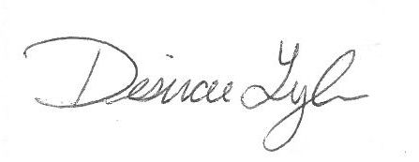
Desirae Lyle
CPB Secretary

