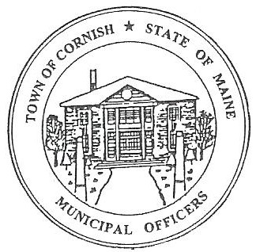
PLANNING BOARD
17 Maple Street
Cornish, Maine 04020
Telephone: 207.625.4324 Fax: 207.625.4416 E-mail: planningboard@cornishme.com

Monday, September 9, 2019
BUSINESS MEETING MINUTES
Call to Order

Chairwoman Jessica Larson called the meeting to order at 6:28 p.m.

Present: Jessica Larson, Eve Bergstrom, Erica Craig, Angel Eastman, Ken, Hall, Sandra Watts, Code Enforcement Officer Wes Sunderland Recorder Desirae Lyle.

Absent: Nancy Perkins

Guests Present: Dan Vaillancourt, Diann Perkins, John Watts

New Business:

- Approve minutes from the June 3, 2019 business meeting, June 17, 2019 workshop meeting, July 1, 2019 business meeting, July 15, 2019 workshop meeting, and the August 5, 2019 business meeting.

Eve Bergstrom made a motion to accept the June 3, 2019, June 17, 2019, July 1, 2019, July 15, 2019 and August 5, 2019 meeting minutes as presented. It was seconded by Erica Craig. Motion carried with all in favor.

- Dan Vaillancourt – Deck Permit in Historic District

Dan Vaillancourt explained that he is building a deck at Lily’s Flower shop; the deck ground framing will be on the old barn that used to be there, he is unsure when it was removed. He confirmed that CEO Wes Sunderland approved the setbacks. It will be a pressure treated deck hopefully with a covered stairway. Wes has approved the project, and the Board agreed that since there was a building there Mr. Vaillancourt does not need to come back before the Board for approval to add a roof to the deck.

Ken Hall made a motion to approve the proposal for the deck at Map/Lot U03-006. It was seconded by Eve Bergstrom. Motion carried with all in favor.

- Mike Jordan – Jordan Harvesting – 688 S. Hiram Rd – U01-006

Mr. Jordan was not present at tonight’s meeting. If he completes his application, he is welcome to attend the workshop meeting on September 16, 2019.

- Correspondence:

  - Karen Hoxie has emailed the Board concerning the flashing sign at Stoneridge Plaza. The Board asked Wes to look into the matter. Route 25 is a state road and Maine DOT (Department of Transportation) can be asked to step in if this continues to be a problem.

  - The Board discussed the letter addressed to Bobby Libby, North County Land, concerning the blanket Conditional Use Permit for Cornish Place Plaza. A copy will be mailed to Mr. Libby and copies will be field accordingly.

  - Abby Sherwin from Southern Maine Planning and development has been notified about the missing planning board ordinance.

  - Erica Craig has been enrolled in the December 5, 2019 Maine Municipal Association Planning/Appeals Board workshop.

  - The Board received an email from Max Tejada about a sign. Jess referred him to Wes.

  - Jess, Angel and Nancy attended the Maine Municipal Association workshop in Saco. Jess and Angel spoke briefly on the subject.

  - Jess sent out an email from MMA about postings for any emergency meetings. It is legal according to Maine Municipal Association to post on the Town website that there is an emergency meeting.

  - Jess has been in contact with Chalmers Insurance about the $25,000 reclamation bond that is required for the new owners of Map U02, Lot 071. Jess has drafted a letter to the new owner, Landpro Alliance, LLC, requiring a $25,000 reclamation bond be acquired before any work starts on the site. Jess read aloud the letter for the Board.

Erica Craig made a motion to approve and send the letter to Landpro Alliance, LLC. It was seconded by Eve Bergstrom. Motion carried with all in favor.

  - The Cornish Selectmen are hosting a Volunteer Appreciation day in Thompson Park on September 14, 2019.

Adjournment:

Angel Eastman made a motion to adjourn the business meeting at 7:20 p.m. It was seconded by Eve Bergstrom. Motion carried with all in favor.

Respectfully Submitted,
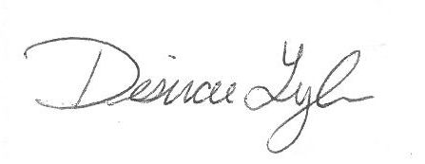
Desirae Lyle
CPB Secretary

