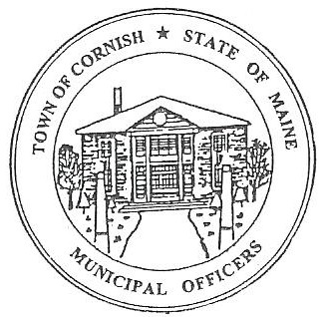
PLANNING BOARD
17 Maple Street
Cornish, Maine 04020
Telephone: 207.625.4324 Fax: 207.625.4416 E-mail: planningboard@cornishme.com

Monday, August 6, 2018
BUSINESS MEETING MINUTES

Call to Order

Chairwoman Jessica Larson called the meeting to order at 6:30 p.m.

Present: Jessica Larson, Eve Bergstrom, Ken Hall, Emily Ward, Nancy Perkins Sandra Watts, Code Enforcement Officer Wes Sunderland, Recorder Desirae Bachelder.

Absent: Stephanie Smith

Guests Present: Jody David, Lydia A, John Watts, Diann Perkins.

Old Business: None

New Business:

- Miscellaneous – Voting Members

Jessica Larson designated Nancy Perkins as a voting member in Stephanie Smith’s absence.

- Approve minutes from July 16, 2018 workshop meeting

There were no minutes available to approve.

- Dalyn Houser – SRCC

Dalyn Houser was not in attendance.

- Jodi David – R08-028A

Jess Larson explained that at the July 16, 2018 this application was discussed. The proposed development is a 40 foot by 80 foot building for Medical Marijuana production. The lot is located in the Agricultural District and the Rural Residential District. Mr. David needs to go through the site plan review process and a conditional use permit is required per the Land Use Ordinances. The site is less than 5,000 square feet which is a minor development. Mr. David has provided the proper documentation that proves he is allowed to produce medical cannabis.
The board read through the submitted site plan review application line by line to confirm that the application is complete.

Nancy asked how any wastewater is dealt with. Mr. David explained that another separate septic system is being installed to facilitate the new building. No permit has been issued for the septic system at this time. The question arose if the setbacks are correct for the proposed building, 30 feet is required and the setbacks will need to be measured again.

The Board read through the Medical Cannabis Ordinance to determine Mr. David’s compliance.

Ken Hall made a motion to schedule a business meeting for August 27, 2018. It was seconded by Emily Ward. Motion carried with all in favor.

A Site Walk was scheduled for August 27, 2019 at 4:00 pm with the business meeting and public hearing to follow at 6:30 pm.

- John & Karen Morrissey – Historic District Application approval

Wes presented the application to the Board. The deck has been modified from the original size of 15 feet by 28 feet to 20 feet by 25 feet. The deck has also been move and now meets the 15 foot setback requirement.

Nancy Perkins motioned to approve the application for a deck as amended. It was seconded by Jess Larson. Motion carried with all in favor.

Communications Received/Sent:

None

Adjournment:

Emily Ward motioned to adjourn the business meeting at 8:10 p.m. It was seconded by Jess Larson. Motion carried with all in favor.

Respectfully Submitted,
Desirae Bachelder
CPB Secretary

