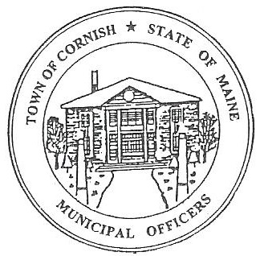
PLANNING BOARD
17 Maple Street
Cornish, Maine 04020
Telephone: 207.625.4324 Fax: 207.625.4416 E-mail: planningboard@cornishme.com

Monday, July 1, 2019
BUSINESS MEETING MINUTES
Call to Order

Chairwoman Jessica Larson called the meeting to order at 6:30 p.m.

Present: Jessica Larson, Eve Bergstrom, Angel Eastman, Nancy Perkins, Sandra Watts, Code Enforcement Officer Wes Sunderland Recorder Desirae Bachelder.

Absent: Erica Craig, Ken Hall

Guests Present: John Watts, Diann Perkins,

New Business:
NOTE: The minutes reflect the order of the agenda in which it was discussed.
- Voting Members

Jess Larson designated Nancy Perkins and Sandra Watts as voting members in the absence of Erica Craig and Ken Hall.

- Approve minutes from the March 25, 2019 workshop meeting, April 15, 2019 workshop meeting, and May 6, 2019 business meeting.

Eve Bergstrom made a motion to approve the minutes from March 25, 2019 workshop meeting, the April 15, 2019 workshop meeting and the May 6, 2019 business meeting as presented. It was seconded by Angel Eastman. Motion carried with all in favor.

- Cornish Variety – CUP – Expiration Date

Jess sent a copy of the Conditional Use Permit to the other Board members as an FYI. The Conditional Use Permit expires in October 2019. Jess spoke with the builder for the project and work should begin soon.

- Correspondence

  - Jess has been contacted by someone wanting to have a mobile Mexican food cart in town. This has been deferred to CEO Wes Sunderland for review.

  - Jess has also been contacted by Julian Morgan who had questions about adult use of recreational marijuana. The questions included if a store front operation would be allowed in town, they are not. Mr. Morgan also asked about Medical Marijuana.

  - John O’Donnell & Associates mapper Mr. Tippy was in the office recently and Jess asked him about updating maps.

  - Southern Maine Planning and Development Commission is planning to have a workshop in October. Jess will update the Board as the meeting gets closer.

  - Diann Perkins has been approached by a citizen with concerns about the freshly painted sign at the Inn at Cornish. Jess explained that because there is no historic district guidelines ordinance there is really nothing the Board can do.

  - Jess has also addressed the waving flag type signs at Rite Aid/Walgreen’s.

  - Nancy asked about the art gallery on Maple Street and when that permit expires. The Conditional Use Permit was approved on September 17, 2019. Ms. Lafforgue has until January 2020 before that permit expires. Work is being done to the building even if the gallery is not open.

- Mike Jordan – Jordan Harvesting U01-006

The applicant was absent from this meeting therefore this agenda item was not discussed.

- Pre-application for subdivision on Route 25 – Richard Humphrey – R01-002

Wes explained that this property is the same one that Michael Humphrey presented to the Board as a gun range. Jess explained that the 21 acres are in the Resource Protection District. In Tables 1 of the Permissible Uses in the Land Use Ordinance under the Resource Protection District subdivisions are not allowed. Wes will follow up with Mr. Humphrey about the subdivision.

Adjournment:

Nancy Perkins made a motion to adjourn the business meeting at 7:22 p.m. It was seconded by Eve Bergstrom. Motion carried with all in favor.

Respectfully Submitted,
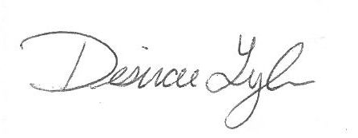
Desirae Lyle
CPB Secretary

