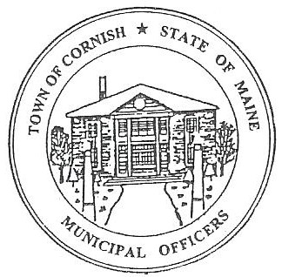
PLANNING BOARD
17 Maple Street
Cornish, Maine 04020
Telephone: 207.625.4324 Fax: 207.625.4416 E-mail: planningboard@cornishme.com

Monday, June 3, 2019
BUSINESS MEETING MINUTES

Call to Order

Chairwoman Jessica Larson called the meeting to order at 6:31 p.m.

Present: Jessica Larson, Erica Craig, Angel Eastman, Ken Hall, Nancy Perkins, Sandra Watts, Code Enforcement Officer Wes Sunderland Recorder Desirae Bachelder.

Absent: Eve Bergstrom

Guests Present: Abby Sherwin, Michael, Wendy and Richard Humphrey, John Watts, Diann Perkins

New Business:

- Humphrey Subdivision

Michael Humphrey and his son Richard and his wife Wendy were present to discuss splitting property. Richard explained that Wendy, his daughter and his other daughter-in-law’s own 72 to 75 acres that used to belong to Nick Watson.

In 2017 Mr. Humphrey had talked to Wes Sunderland about a building permit for one lot of a family subdivision. He explained that lots were not divided and recorded but were staked out to be ready for family members to build on. They have spoken with their lawyer about splitting the property, and since the property is in an LLC the lawyer explained that the Humphreys would need Town approval to see if it met the criteria for a family subdivision. One lot has been split for Richard, which he has built on. Mr. Humphrey’s grandson would like a lot to build on. It is a family owned LLC.

Jess explained that the Board has recently reviewed a subdivision and she would like to look through the Town ordinances to see if what they say about family subdivisions. Jess explained that the Town ordinances reference M.R.S.A. 4401 (4) which state that a subdivision is a division of a tract or parcel of land into three or more lots within any five years. There are very few exemptions to the subdivision laws. Mr. Humphreys 4.5 acre lot was divided from the property in June of 2017 splitting another piece off of the property at this point would trigger a subdivision, because it’s within five years. Jess explained that she thinks that the subdivision laws have been changed at the State level. The Board is looking at a 75 acre parcel that already has one dwelling on it. There has been a 3 acres split that has been recorded at the Registry of Deeds. Another lot has been described but not recorded. There is already a house on the described lot; the grandson’s lot is still to be determined which would be the third split triggering a subdivision.

The Board reviewed the definition of a multi-family dwellings. Jess read aloud the definition for Multi-Family Dwellings: A building containing three (3) or more dwelling units, such buildings being designed exclusively for residential use and occupancy by three (3) or more families living independently of one another, with the number of families not exceeding the number of dwelling units.

Jess explained that the Board had received legal counsel on a previous subdivision and it was brought to their attention that the subdivision laws have no exceptions. But the family aspect is a new twist. Jess suggested sending an email to MMA (Maine Municipal Association) regarding the subdivision with the family owned LLC aspect and see what they say about it.

Desirae Bachelder read aloud M.R.S.A. Title 30-A§4401 Definitions - D-4. A division accomplished by gift to a person related to the donor of an interest in property held by the donor for a continuous period of 5 years prior to the division by gift does not create a lot or lots for the purposes of this definition, unless the intent of the transferor is to avoid the objectives of this subchapter. If the real estate exempt under this paragraph is transferred within 5 years to another person not related to the donor of the exempt real estate as provided in this paragraph, then the previously exempt division creates a lot or lots for the purposes of this subsection. "Person related to the donor" means a spouse, parent, grandparent, brother, sister, child or grandchild related by blood, marriage or adoption. A gift under this paragraph cannot be given for consideration that is more than 1/2 the assessed value of the real estate.

Jess interpreted that to mean that you can gift a parcel to a family member, but they don’t want you to turn around and sell it within five years of being gifted. Another question is that if the LLC is dissolved does that change the situation.

Nancy Perkins asked if the land that the grandson wants to build on will be deeded to him.

- Southern Maine Planning and Development – Discussion per 5/20/2019 Meeting

Jess Larson updated the Board on what was discussed at the May 20, 2019 workshop meeting. There was a lot of discussion about definitions and formatting. Abby will be creating a blanket statement concerning definitions that might be found in other ordinances. Jess has researched the City of Saco’s Home Occupation Permit which was adopted March 31, 2019; she would like to discuss this with Abby and consider updating Cornish’s ordinances.

- Correspondence

  - MMA (Maine Municipal Association) Planning/Appeals Board workshop on Tuesday, July 30, 2019 in Bethel. Any Planning Board members who would like to attend need to register.

  - Jess asked Wes if he had heard about the Singing Bowl at 22 Main St and if he had looked into it yet. Jess explained that she was under the assumption that 22 Main Street had permits for 2 offices upstairs. The first and second floors are commercial use. Wes is working with the Selectmen to bring 22 Main Street in compliance with Town ordinances. The owner of 22 Main Street does need to come before the Planning Board with an application to change the use of the second floor.

  - Jess explained that Jack Wadsworth had been required to have a $25,000 Reclamation bond for his extraction business on Map/Lot R02-071. Mr. Wadsworth has sold the property and Jess would like Wes to reach out to the new owners concerning a new bond. Wes has spoken to the Road Commissioner Bob Sturgeon and it is being worked on.

  - Desirae Bachelder reported that it was brought to her attention that the second floor of the York property on Main Street has been rented as an apartment. Jess asked Wes to look into this because the owner has put in a second floor apartment and did not get a permit for it.

  - Desirae Bachelder also stated that she had been asked about the house across from 31 Maple Street. Nancy Perkins stated that it is being rehabilitated.

Adjournment:

Angel Eastman made a motion to adjourn the business meeting at 7:37 p.m. It was seconded by Erica Craig. Motion carried with all in favor.

Respectfully Submitted,
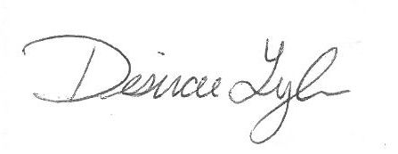
Desirae Lyle
CPB Secretary

