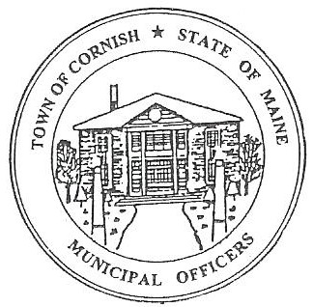
PLANNING BOARD
17 Maple Street
Cornish, Maine 04020
Telephone: 207.625.4324 Fax: 207.625.4416 E-mail: planningboard@cornishme.com

Monday, February 4, 2019
BUSINESS MEETING MINUTES

Call to Order

Chairwoman Jessica Larson called the meeting to order at 6:30 p.m.

Present: Jessica Larson, Eve Bergstrom, Nancy Perkins, Sandra Watts, Code Enforcement Officer Wes Sunderland, Recorder Desirae Bachelder.

Absent: Ken Hall

Guests Present: John Watts, Debra Furlong, Denise Benton, Rick & Lori Rowland,

New Business:

- Miscellaneous – Voting Members

Jess Larson designated Nancy Perkins and Sandra Watts as voting members in Ken Hall’s absence.

- Debra Furlong – Subdivision – R08-039B

The board received the amended information from Main-Land Consultants concerning Ms. Furlong’s subdivision. The amendment is for a two lot, four unit subdivision, it now meets the Cornish Land Use Ordinance and State requirements.

Jess Larson made a motion to approve the revised Furlong subdivision application for a two lot, four unit subdivision, as presented in the January 15, 2019 correspondence and plot plan that was provided, along with the review that took place at the January 28, 2019 workshop meeting. It was seconded by Eve Bergstrom. Motion carried with all in favor.

The board signed the copies of the Mylar maps that will be recorded at the Registry of Deeds. A recorded copy of the map will be returned to the Board.

- February Workshop Change of Date

Jess Larson made a motion to change the February 18, 2019 workshop date to February 25, 2019 due to the President’s Day Holiday. It was seconded by Nancy Perkins. Motion carried with all in favor.

- March Workshop Change of Date

Eve Bergstrom made a motion to change the March 18, 2019 workshop date to March 25, 2019 due to the Cornish Annual Town Meeting. It was seconded by Nancy Perkins. Motion carried with all in favor.

- Miscellaneous – Board Resignation

Emily Ward has resigned her position on the planning board. The Selectmen have been made aware of this. Openings on the planning board have been advertised in Your Weekly Shopping Guide.

- Miscellaneous – Cornish Variety

Jess has been asked by the selectmen about Cornish Variety. Their Conditional Use Permit was issued on April 16, 2018, according to Land Use Ordinance Article 4, Section 6, expiration of Planning Board permits is 18 months. Their CUP will expire in October of 2019. Wes stated that Mr. Alsudany is waiting for his financials to fall into place.

- Miscellaneous – Southern Maine Planning and Development Commission

The board discussed the contract with SMPDC and the scope of work that SMPDC is going to do updating the Cornish Land Use Ordinances. Nancy will contact Paul Schumacher and Abby Sherwin about attending the February 25, 2019 workshop meeting.

Communications Received/Sent:

None

Adjournment:

Jess Larson made a motion to adjourn the business meeting at 7:15 p.m. It was seconded by Eve Bergstrom. Motion carried with all in favor.

Respectfully Submitted,
Desirae Bachelder
CPB Secretary

