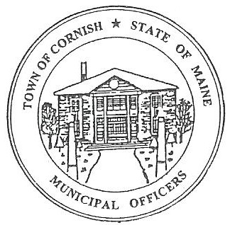
vcz PLANNING BOARD
17 Maple Street
Cornish, Maine 04020
Telephone: 207.625.4324 Fax: 207.625.4416 E-mail: planningboard@cornishme.com

Monday, November 4, 2019
BUSINESS MEETING MINUTES
Call to Order

Chairwoman Jessica Larson called the meeting to order at 6:30 p.m.

Present: Jessica Larson, Eve Bergstrom, Angel Eastman, Ken, Hall, Nancy Perkins, Sandra Watts, Code Enforcement Officer Wes Sunderland, Recorder Desirae Lyle.

Absent: Erica Craig

Guests Present: Karl Butterfield, John Watts

New Business:

- Miscellaneous

Jess Larson designated Nancy Perkins as a voting member in Erica Craig’s absence.
- SMPDC – Abby Sherwin

Abby Sherwin was not present at tonight’s meeting, but will be attending the workshop meeting on November 18, 2019.

- Approve minutes from August 19, 2019 workshop meeting.

Ken Hall made a motion to accept the August 19, 2019 workshop meeting minutes as presented. It was seconded by Eve Bergstrom. Motion carried with all in favor.

- Approve minutes from September 9, 2019 business meeting.

Eve Bergstrom made a motion to accept the September 9, 2019 business meeting minutes as presented. It was seconded by Nancy Perkins. Motion carried with all in favor.

- Karl Butterfield – Proposed Smoke Shop

Jess Larson confirmed that Call’s Plaza has a blanket Conditional Use Permit. Mr. Butterfield would like to open a Vape/Smoke Shop in Call’s Plaza. He’s intent is to lease the space next to the Post Office and sell e-cigarettes, lighters, tobacco, glass pipes, etc. Nancy Perkins would like Mr. Butterfield to provide written documentation of what he is planning for his business.

Jess Laron advised Mr. Butterfield that Cornish has a Headshop Ordinance. Jess read aloud the definition of a headshop. The definition is a building or place where drug paraphernalia is sold or offered for sale or where merchandise is displayed for the purpose of sale or the purpose of promoting sales and whether even the nature of the merchandise or the nature of some of the merchandise in content (context?) in which it is displayed would indicate to a reasonably knowledgeable person that some of the merchandise is equipment, products or materials designed or marked (Marketed?) for use as drug paraphernalia. An establishment which meets this definition is considered a head shop, notwithstanding that it may also sell or display other types of merchandise. Drug Paraphernalia means all equipment, products and materials that are defined in Title 17-A which is the Maine criminal code 45 section 118. Head shops are prohibited from operating within 1,000 feet of a church, school or park. Head shops are also prohibited from operating in the Rural Residential District, Residential District, Historic District Overlay, Aquifer Protection and the Shoreland District etc. Head shops are only allowed in the Industrial Park and Commercial District. Since Mr. Butterfield is planning to sell glass pipe he will need a Conditional Use Permit. Jess explained that there can be no signs that contain head shops, bongs, ice chillers, water pipes, chillum pipes, roach clips, air driven pipes or anything defined as drug paraphernalia found in Title 17-A shall be erected, posted or in any way displayed on the outside of the property or establishment. Mr. Butterfield should work with Wes on a Conditional Use Permit Application.

The Board discussed concerns that the building could be within 1,000 feet of the Cornish ball fields and trotting park. The soccer fields are behind Call’s Plaza, the Board asked that Wes Sunderland look into the distance from Call’s to the soccer and ball fields. There was some discussion about whether the 1,000 feet is determined from the distance from the building to the parks or from the property line to the parks. The Water District is also on the other side of the ball fields, Wes should look into the distance to the Aquifer Protection. Nancy suggested that Wes measure from the Trotting Park to the building as well as the soccer and ball fields. The Board suggested that Wes should contact Maine Municipal Association for clarification on the 1,000 feet measurements.

The Board discussed the contents of a smoke shop. Ken Hall suggested that the Selectmen should be kept in the loop as this project progresses.

- Solar Power Discussion

Jess explained that she has received multiple phone calls regarding individuals interested in solar power. One is by the sand pit on Cumberland Street and the other is Highland Farms on Towles Hill Rd. Jess mentioned that Governor Mills has approved LD 17-11 concerning solar power. Jess has been looking into other town’s solar power ordinances. The Board extensively discussed solar power, how it works and the aesthetics.

Solar Power Companies are the manufacturers, they produce a product which is energy. That product goes to an intermediary or wholesaler like CMP (Central Maine Power) then it goes to the residents. The residents can choose to go through CMP or have solar farms installed on their property. Jess directed the Board to the definitions. Public Utility: Any person, firm, corporation, Town department, board or commission authorized to furnish gas, steam, electricity, waste disposal, communication facilities, transportation or water to the public. Solar Farms have subscribers if they are not providing service to the public they would not fit under this definition.

- Miscellaneous

Nancy Perkins asked if it is possible for Wes to give a progress report of the year concerning the progress in Town including building permits issued and were the big development areas are. Jess agreed and suggested asking Wes to report quarterly.

She also advised the Board that there is an attempt to bring homeless shelters to SAD 55 soon. Nancy doesn’t know for sure where they will be but felt that the Board should know that this is happening.

Adjournment:

Eve Bergstrom made a motion to adjourn the business meeting at 7:50 p.m. It was seconded by Nancy Perkins. Motion carried with all in favor.

Respectfully Submitted,
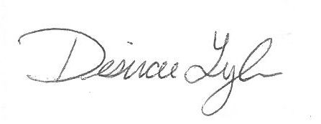
Desirae Lyle
CPB Secretary

