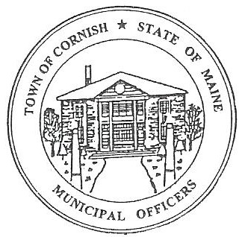
PLANNING BOARD
17 Maple Street
Cornish, Maine 04020
Telephone: 207.625.4324 Fax: 207.625.4416 E-mail: planningboard@cornishme.com

Monday, October 7, 2019
BUSINESS MEETING MINUTES
Call to Order

Chairwoman Jessica Larson called the meeting to order at 6:31 p.m.

Present: Jessica Larson, Eve Bergstrom, Erica Craig, Angel Eastman, Ken, Hall, Nancy Perkins, Code Enforcement Officer Wes Sunderland, Recorder Desirae Lyle.

Absent: Sandra Watts

New Business:

- Correspondence

- The Board received an email from Dan Davis, chairmen of the Porter Planning Board with questions about how the Cornish Planning Board operates. Jess has responded to Mr. Davis.

- The Heritage Small Foundation has purchased 30 acres of land on the Saco River and will be holding an informational meeting on Thursday, October 10, 2019 here at Pike Hall. Shoreland Zoning will need to be looked at and Saco River Corridor Commission will need to be involved with any development.

- Map U04-040-A is shown on the zoning maps in different zones between the large map and the blown up map. Jess Larson has been in contact with John O’Donnell and Associates; they will be updating the Cornish zoning maps. O’Donnell’s confirmed that the property is in Residential District not Commercial District like one of the maps shows.

- The Board briefly discussed the Residential District and in home businesses versus classes.

- Eve Bergstrom spoke briefly about the legislative updates to the building codes.

- Jess Larson suggested to the Board that since there were no agenda items tonight and Abby Sherwin from Southern Maine Planning and Development Commission isn’t scheduled to come back until the November 4, 2019 business meeting, that the October 21, 2019 workshop should be cancelled.

Angel Eastman made a motion to cancel the October 21, 2019 workshop meeting. It was seconded by Erica Craig. Motion carried with all in favor.

Jess will place an ad in the notices of Your Weekly Shopping Guide, and she will talk to Monique about putting something on the website.

Adjournment:

Angel Eastman made a motion to adjourn the business meeting at 7:00 p.m. It was seconded by Erica Craig. Motion carried with all in favor.

Respectfully Submitted,
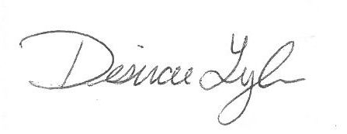
Desirae Lyle
CPB Secretary

